**Fi-Ware Social Proximity App**

Project Report

Joshua Eisikovits: C00156665

Project Supervisor: Dr Chris Meudec

17/04/2015

Table of Contents

Introduction 3

Purpose and Content 3

Project Brief 3

Submitted Project Description 3

Mobile Client 3

Web Application 4

Register – Web Application 5

Create Event – Web Application 5

Final Product 6

Fi-Ware Technology 6

Final Product – Mobile Application 6

Final Product – Web Application 6

Conformance to Specification and Design 7

Introduction

Purpose and Content

The purpose and content of this document is to outline all work that has been completed to date on the Fi-Ware Social Proximity Application. The document will also cover in detail any work that is outstanding on the project in order to complete it to the final product version standard.

Also contained within this document are descriptions of all problems that were encountered while creating the Fi-Ware Social Proximity App as well as any solutions found.

Project Brief

Fi-Ware Social Proximity is a dual application consisting of a mobile application and a web application. The mobile application allows user to create a custom profile based on their current location and current interest. Whereas the web application allows an event organiser to login/register as well as create an event. Each event contains details such as name, position and even an event logo. Both applications use REST API techniques to transfer data to and from a MySQL database which is hosted on the Fi-Ware Cloud Virtual Machine.

Submitted Project Description

Mobile Client

The submitted application allows the user to login as a guest or using their social network account Facebook. The user is also allowed to create a profile which automatically locates their current position the user then has a list of current interests to choose from.

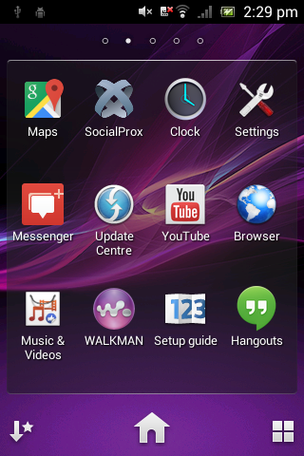

Once the user has installed SocialProx the application will be available for the user.

Create Profile - Mobile App Map View - Mobile App

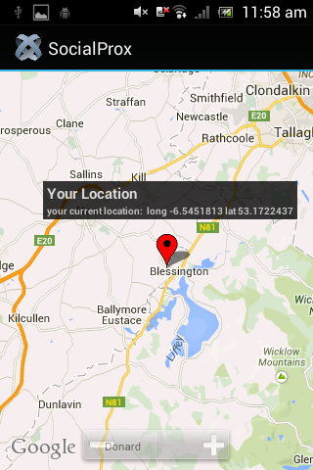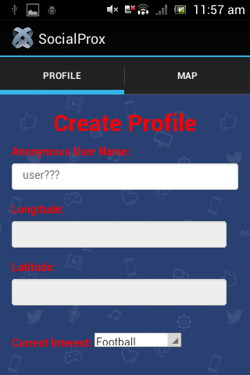

Web Application

The submitted application allows the user to login to the web application if they are registered. If a user is not registered they can register to the web application. Registered users can also create events.

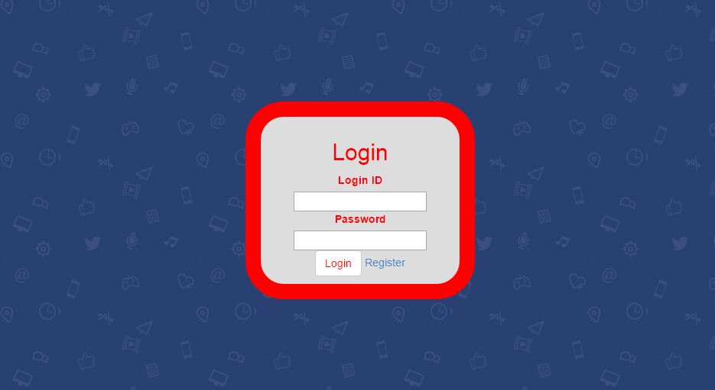Login – Web Application

Register – Web Application

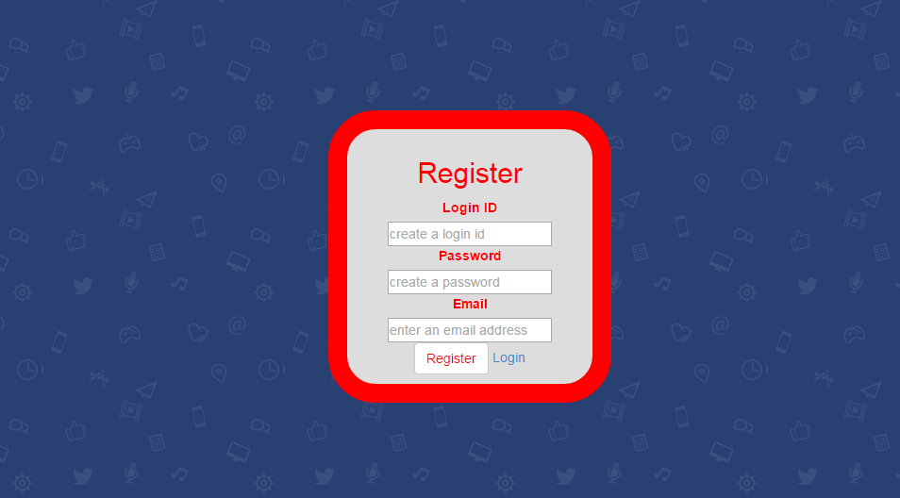

Create Event – Web Application

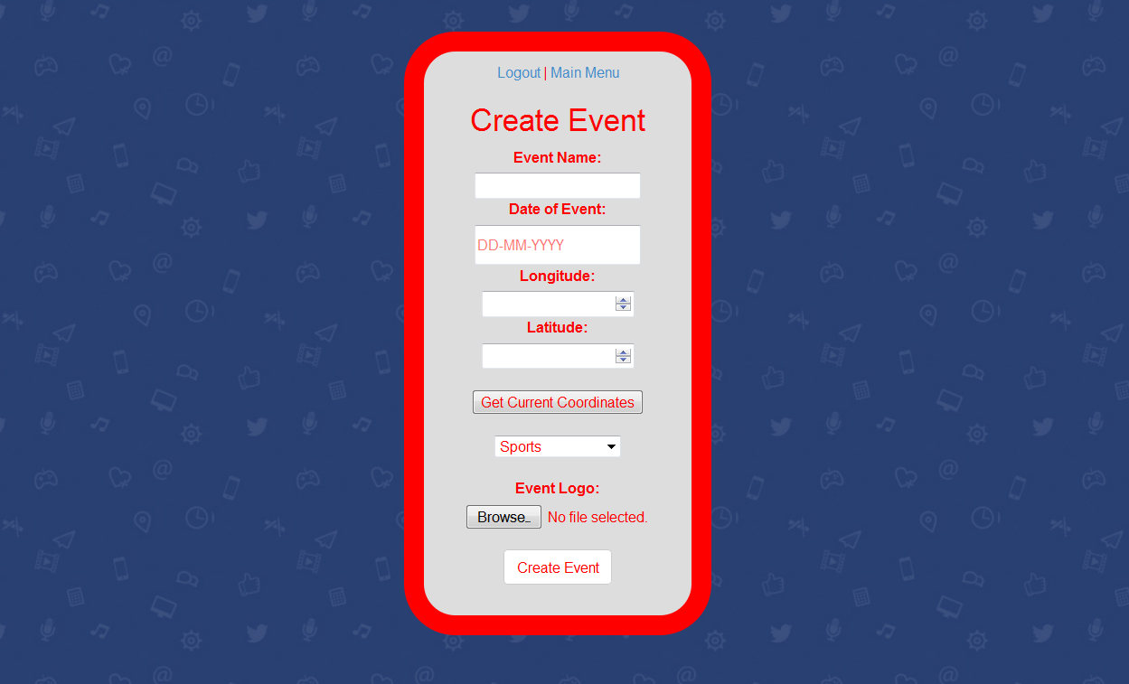

Final Product

The final release of Fi-Ware Social Proximity Application lacks some functionality which was mentioned in the functional specification and design documents.

However throughout the project I was able to complete the following;

Fi-Ware Technology

I was able to create a virtual machine using Fi-Lab. I also created security rules, a floating IP address as well as open network ports for incoming traffic to the virtual machine. However I was unable to implement the use of Generic Enablers in my project. I struggled a lot during the first iteration trying to come to terms with the Fi-Ware technology.

As I fell further behind throughout the duration of the project I was happy to have a working virtual machine in which I could install software (Java, Apache & MySQL). This was a major factor of the project if I was unable to have connectivity between the mobile/web applications and Fi-Ware it would have been near impossible to pass as it was compulsory to use the Fi-Ware technology.

Final Product – Mobile Application

1. Sign in as a guest or using Facebook.
2. Create User Profile
   1. Automatically acquires GPS of phone, indoor accuracy is very accurate.
   2. Allows user to add current interest from a selected list.
3. View user current position of Google Map
4. Create profile is stored on remote server using MySQL database.

Final Product – Web Application

1. Register Event Organiser
2. Login Event Organiser
3. Create Event
   1. Allows event organiser to upload image of event
   2. Acquires current position (longitude and latitude depending on browser)
4. Create event is stored on remote server using MySQL database.

Conformance to Specification and Design

The final release product of Fi-Ware Social Proximity Application matches the ‘External Interface Requirements ‘ under ‘Specific Requirements’ in my Functional Specification Document as I think my application really does grasp simplicity for the user.

Nevertheless it also matches the ‘Communication Interface’ mentioned in the sub section. I was also able to implement communication with Facebook and Google Maps API.

Originally the projected specification of the application was to build a mobile application with a separate web application which would have features for other users such as event organisers. The initial plan from my research was to create a Hybrid Application using Titanium Appcelerator which would work on multiple devices (Android/iOS/Windows Phone etc.) using one code base JavaScript. This was achieved as the mobile application was developed using this development tool throughout the project.

The submitted application is a combination of a hybrid mobile application and a web application. The hybrid mobile app was developed using the proposed technologies that I came across during my research. The technologies implemented were;

1. JavaScript – the core work of the application was written in JavaScript.
2. HTML5 – Used for web based form applications.
3. CSS – styling and designing of HTML pages.
4. REST API (HTTP methods, POST, GET, PUT etc.) to transfer HTML form data to a remote server.

The web application was developed using Java, Java Servlet Pages and HTML. Both applications communicate via Java Servlet pages (hosted on Apache Tomcat) using REST API methods to store and retrieve information on a MySQL database, both Apache Tomcat and MySQL were manually installed on the Fi-Ware Virtual Machine.

MySQL was the only relational database I covered in my research document as I knew during the second iteration I was running out of time and didn’t have enough time to go and research other databases. I came to the conclusion that I would stick to technologies that I had experience with prior to the project so that I would not fall further behind.

Description of Learning

Conformance to Specification and Design

Throughout the duration of the Fi-Ware Social Proximity project I have learned a lot about different technologies and platforms.

Firstly was setting up a virtual machine on the Fi-Ware Infrastructure. I was able to create a virtual machine (CentOS Linux operating system) assign a floating IP address to this instance so that I could access the virtual machine from an external computer. I was then able to open TCP/UDP ports to allow traffic in and out of the virtual machine. After the virtual machine was set up I was able to download certain software (Java, Apache Tomcat and MySQL) via command line using Xubuntu operating system. I feel that I have come quiet competent and comfortable directing m self around the virtual machine using just the command line interface.

Secondly was the ability to develop an Android application using the Titanium Appcelerator IDE. I was able to use web technologies such as JavaScript, HTML and CSS to produce an Android application that is able to locate the user position as well as communicate with a remote server to store information on a MySQL database.

Furthermore, I also learned how to make beneficial use of Java Servlets and Apache Tomcat for this project. I was able to write multiple Java Servlets programs which acted as middle layer between the Tomcat Web Server and Mobile Client. Using Java Servlets I was able to collect input from the mobile client through web paged forms and store in a MySQL database using JDBC API (Java Database Connectivity).

Throughout the project I learned a lot about JDBC such as how to

1. Connect to the MySQL database on the virtual machine.
2. Create SQL statements to query tables on the MySQL database.
3. Executing the SQL statements.

Learning how to create Java Servlets with the JDBC API connectivity for MySQL database also allowed me to further develop the project by creating a web based application. Using Java Servlets I was able to take advantage and allow users to upload images to the web application which could be stored on the MySQL database. If I was to use Java and Java Servlets again in the future to work with a relational database, thanks to this project I feel that I would not have a problem working with these technologies again.

Personal Learning